**AZURE BOARDS-FOR AMAZON PAYMENT EPIC:**

**Steps to Create the Agile Board**

**Step 1: Create Azure DevOps Project**

* Logged in to Azure DevOps.
* Clicked on **New Project**.
* Entered details:
  + **Project Name:** Amazon Pay Project
  + **Visibility:** Private (team members only)
  + **Version Control:** Git
  + **Work Item Process:** Agile

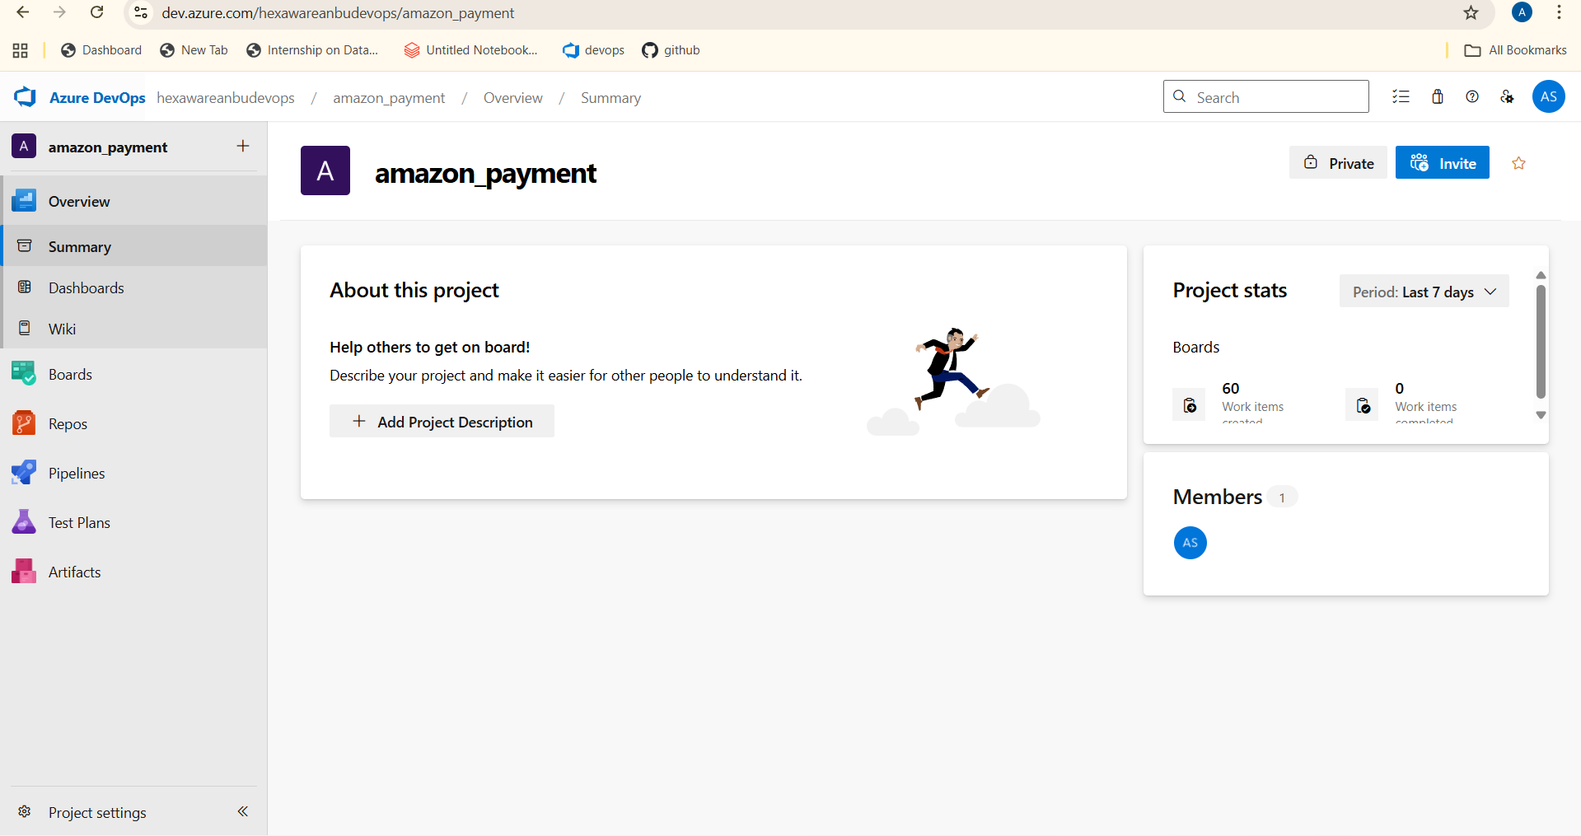

**Step 2: Configure Teams and Permissions**

* Created team members for the project.
* Assigned roles such as **Product Owner, Scrum Master, Developers, and Testers**.
* Provided required access permissions to each member.

**Step 3: Setup Agile Board**

* Navigated to **Boards → Boards**.
* Added **columns** to represent workflow:
  + **To Do** → **In Progress** → **Review/Testing** → **Done**
* Customized board settings:
  + Enabled WIP (Work In Progress) limits.
  + Configured card styles for priority items.
  + Added tags like *High Priority, Enhancement, Bug*.

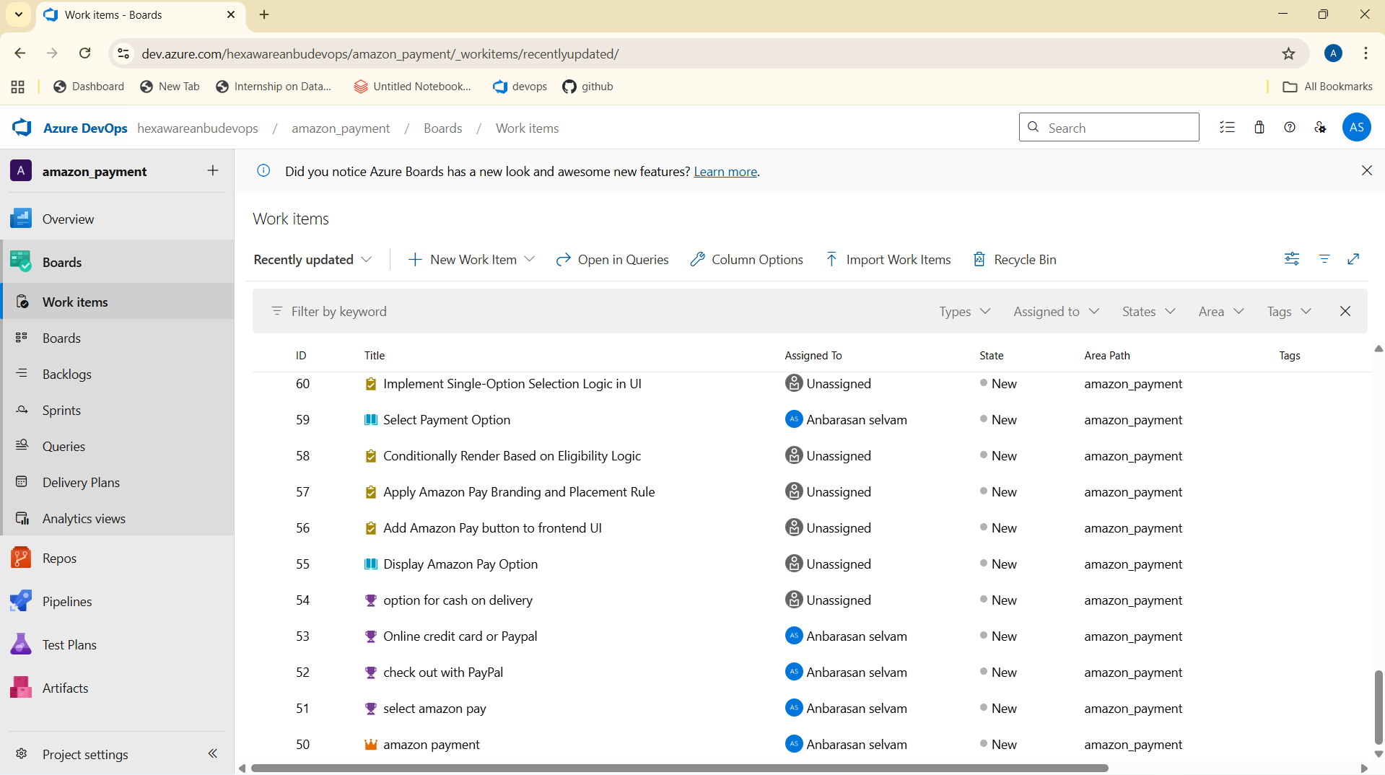

**Step 4: Create Work Items**

* Defined **Epics** (e.g., Amazon Pay Integration).
* Created **Features** under each Epic (e.g., Checkout with PayPal, Cash on Delivery).
* Added **User Stories** for each feature.
* Broke down user stories into **Tasks** (e.g., UI development, API integration, testing).
* Linked **bugs** with user stories where applicable.

In the below section the screenshot of EPIC is attached.

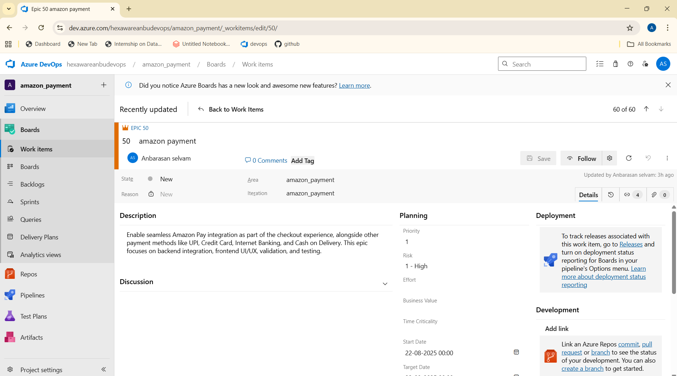

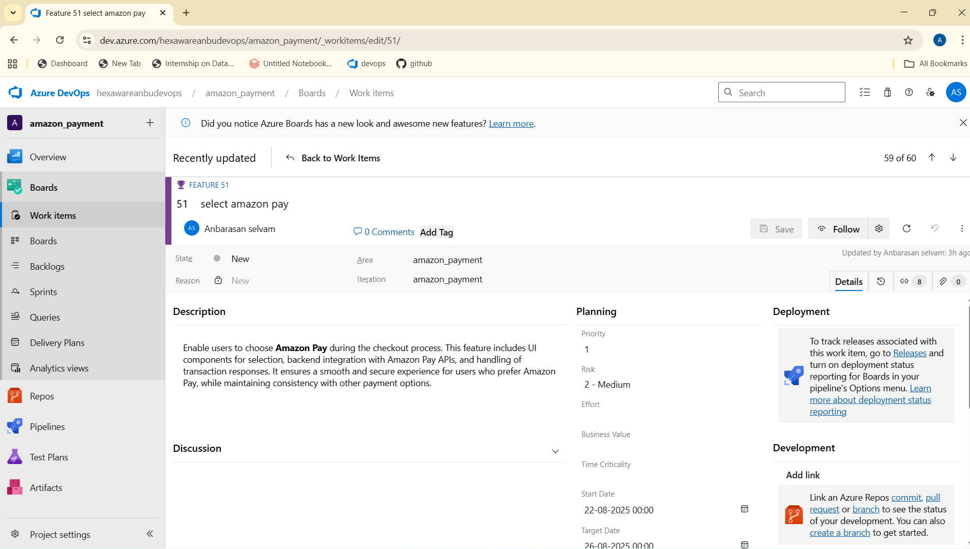

The image attached above is the sample feature screenshot .(feature-select amazon pay).

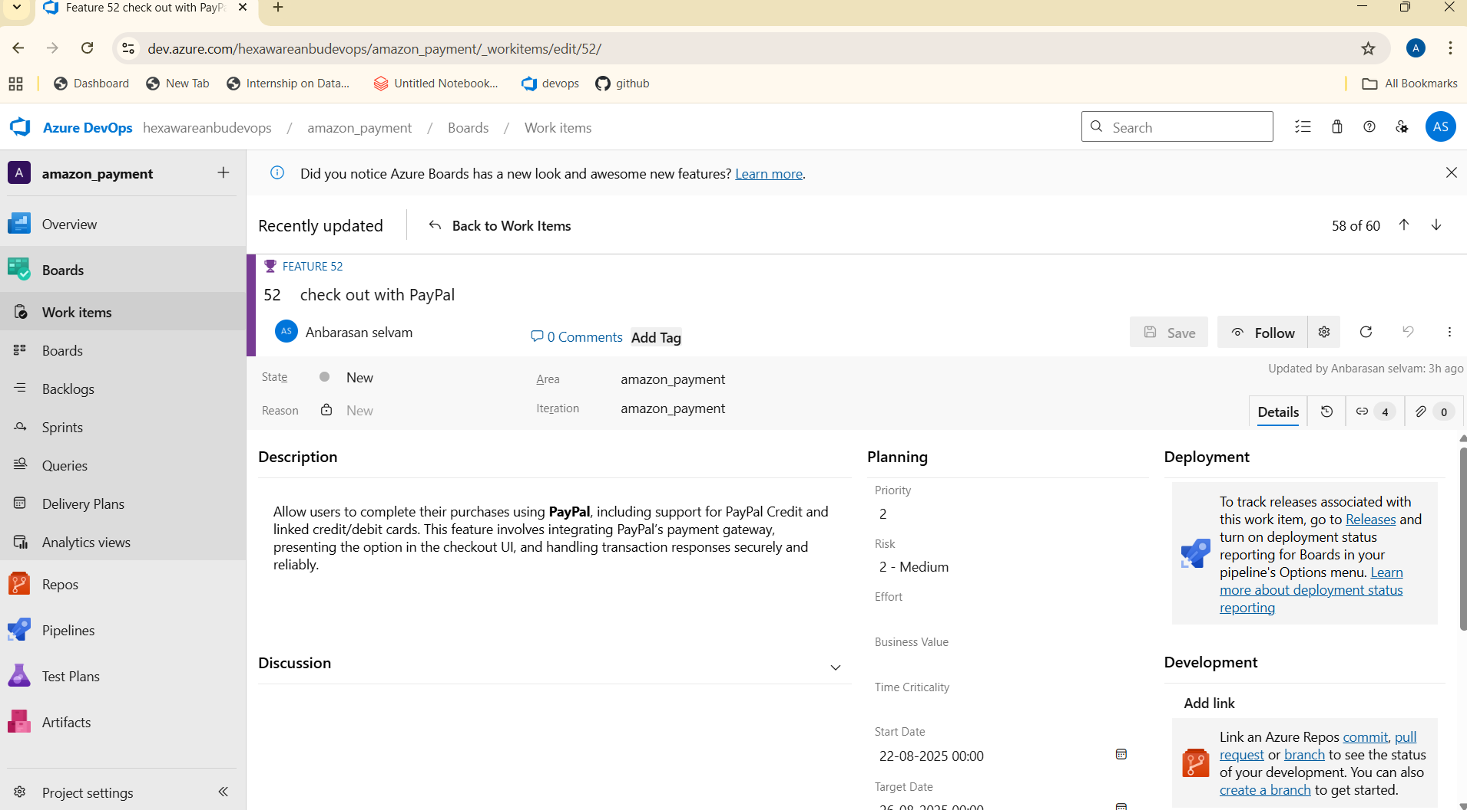

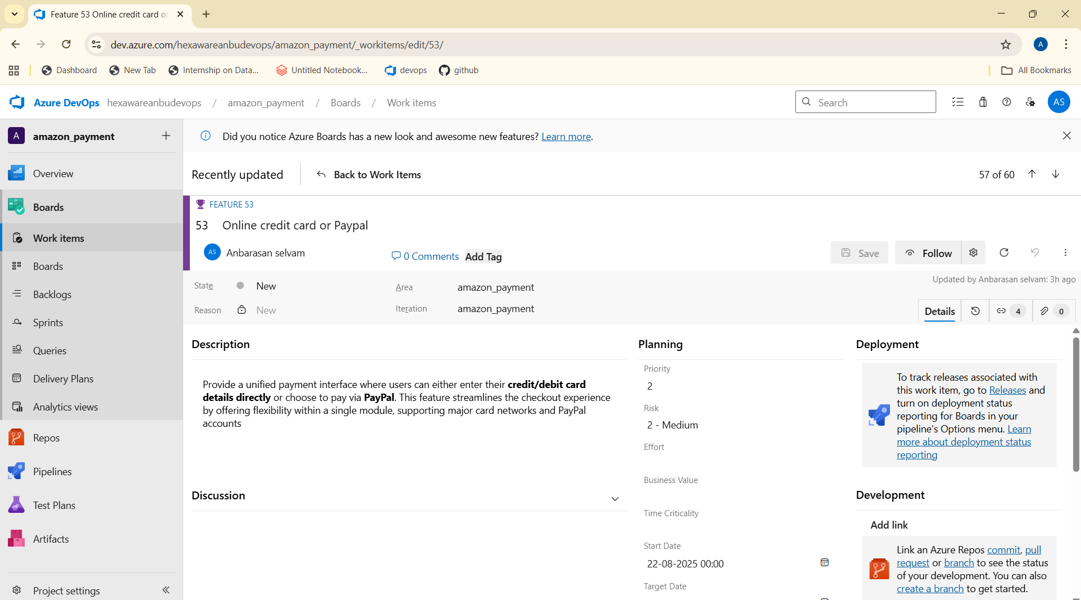

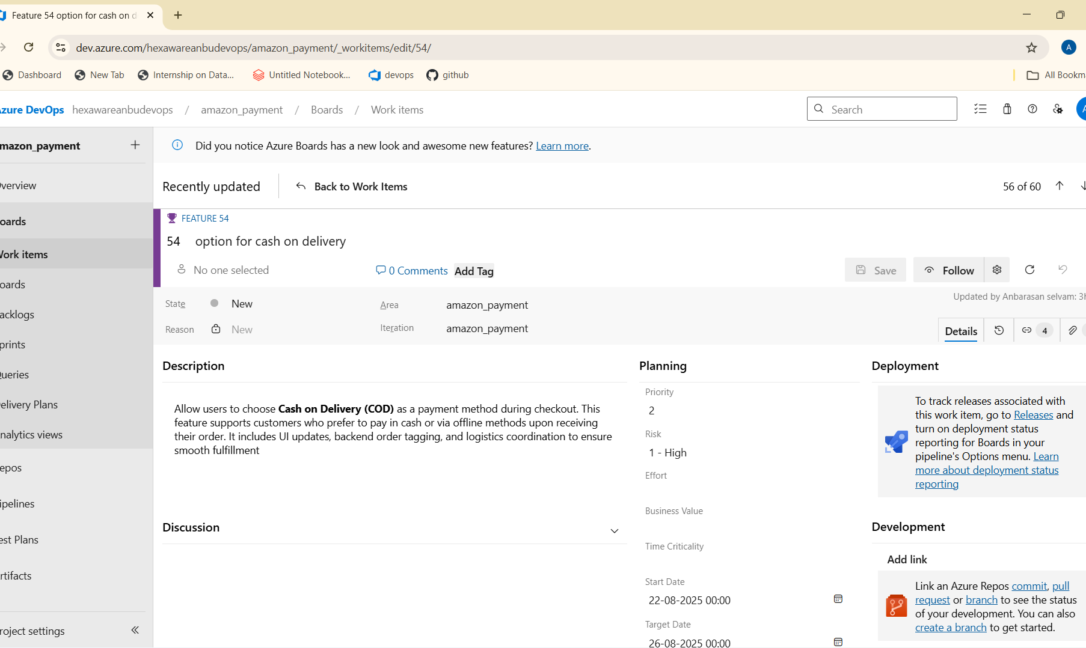

The images are the different features in the epic.

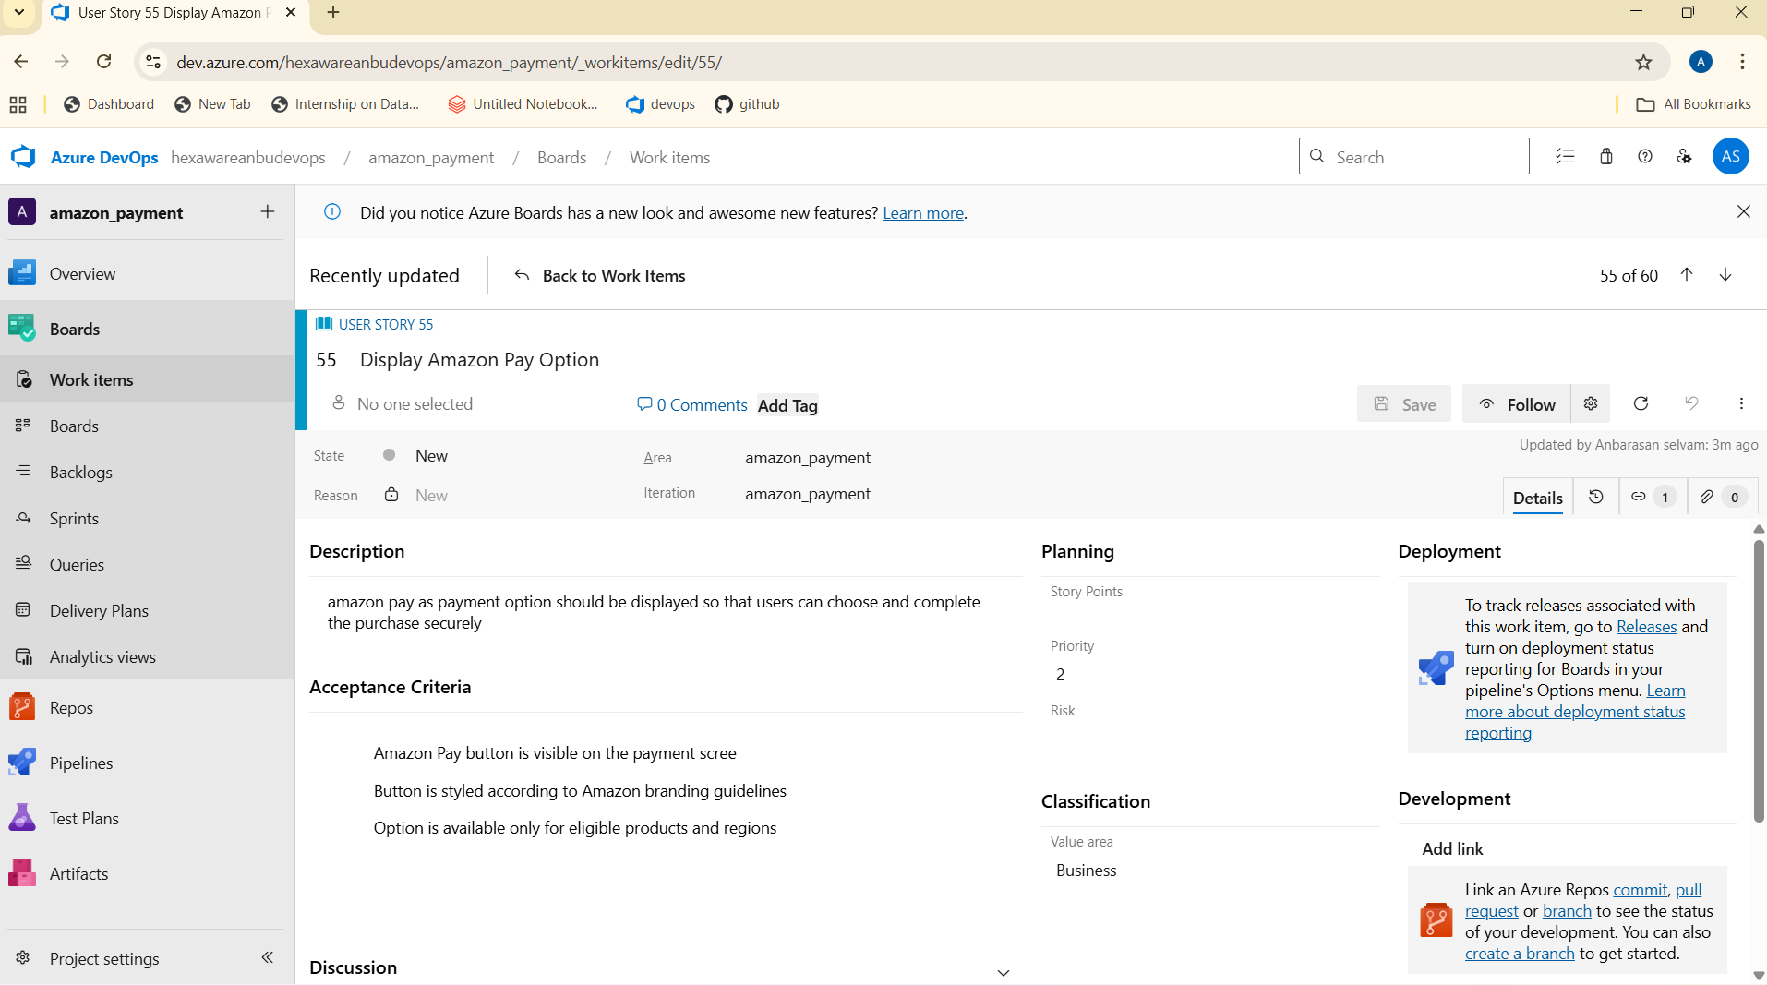

The image attached above is the sample of user stories.

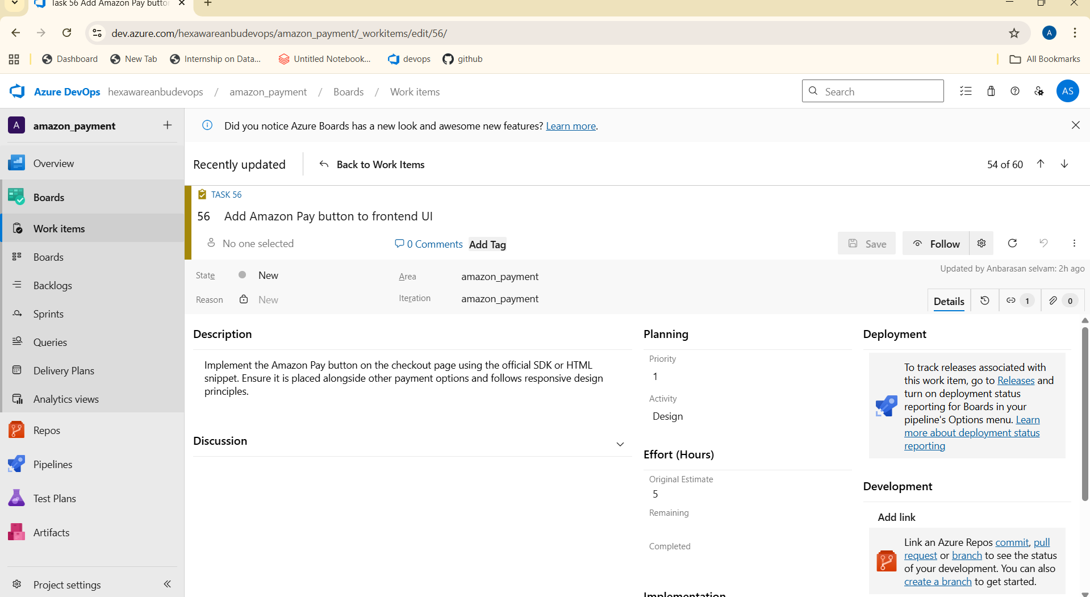

The image attached above is the sample screenshot of tasks.

**Totally there is 50+work items created to make this project, and the images of all work items and their title is listed shortly below.**



